**Home page**

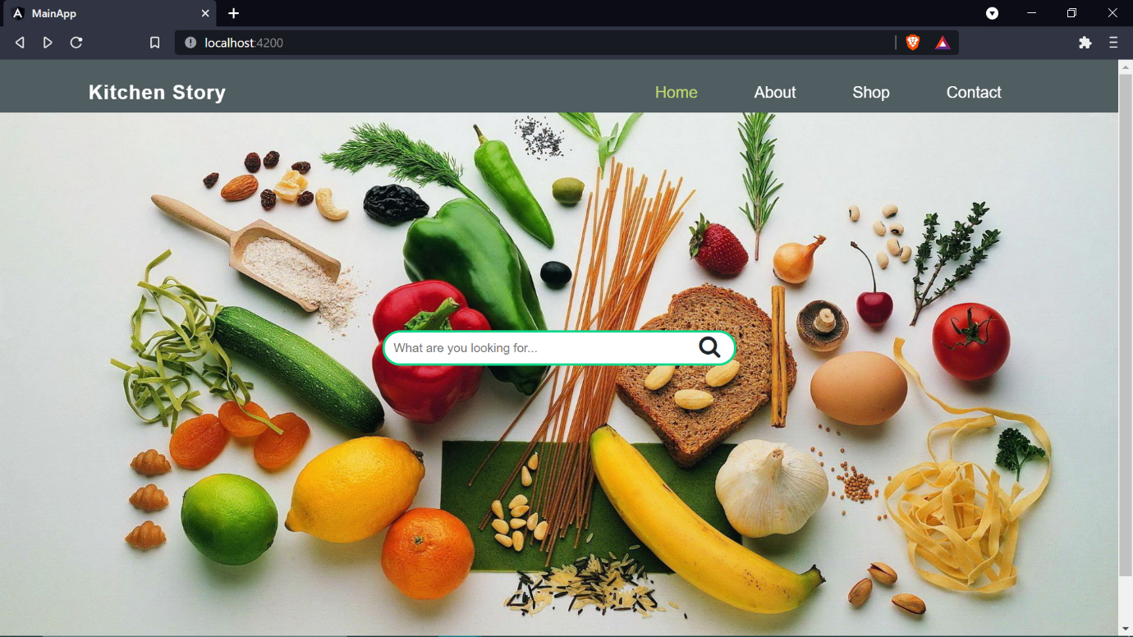

**About us Page**  
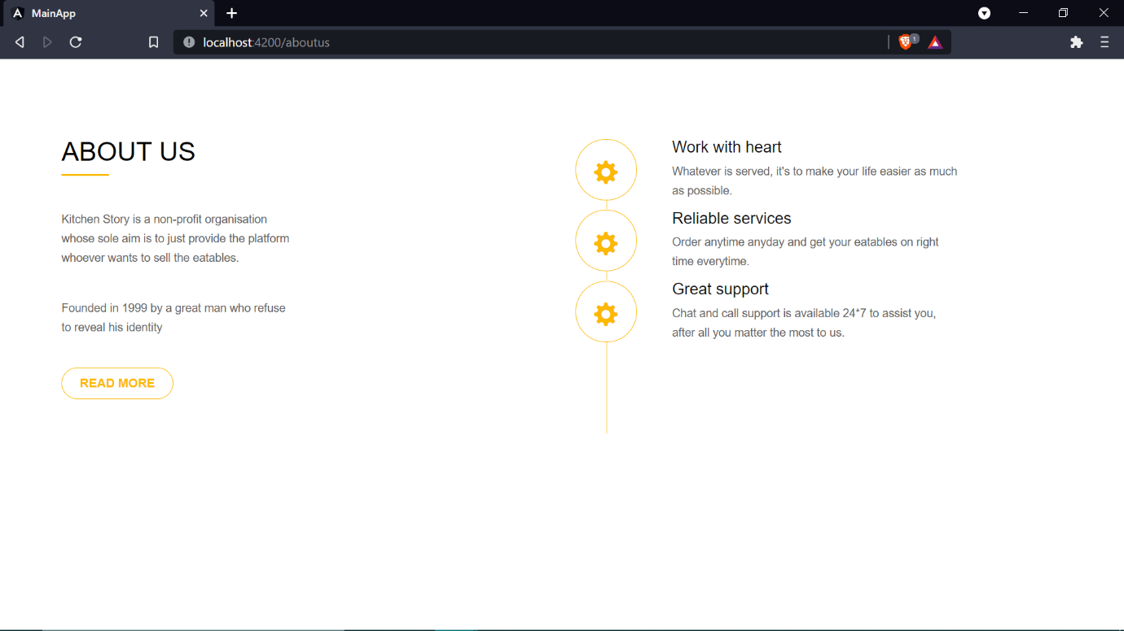

**Shop Page.**  
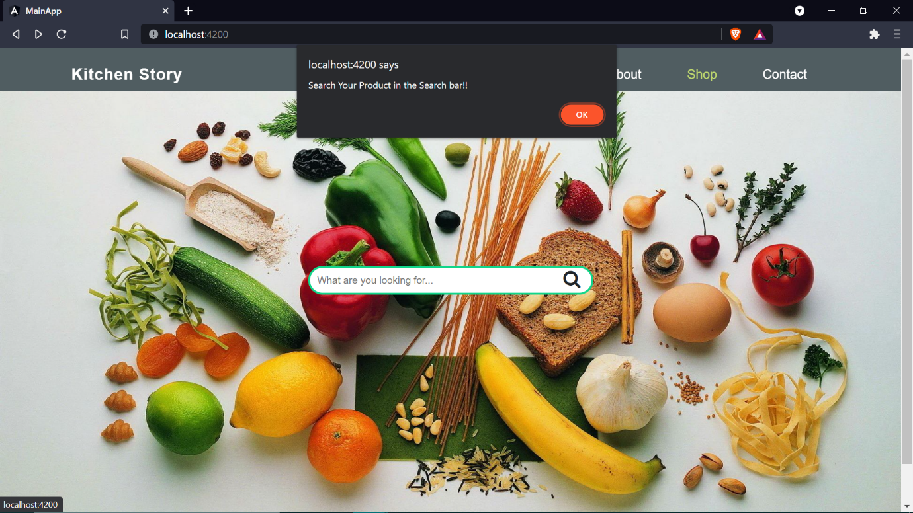

**Contact Us page.**  
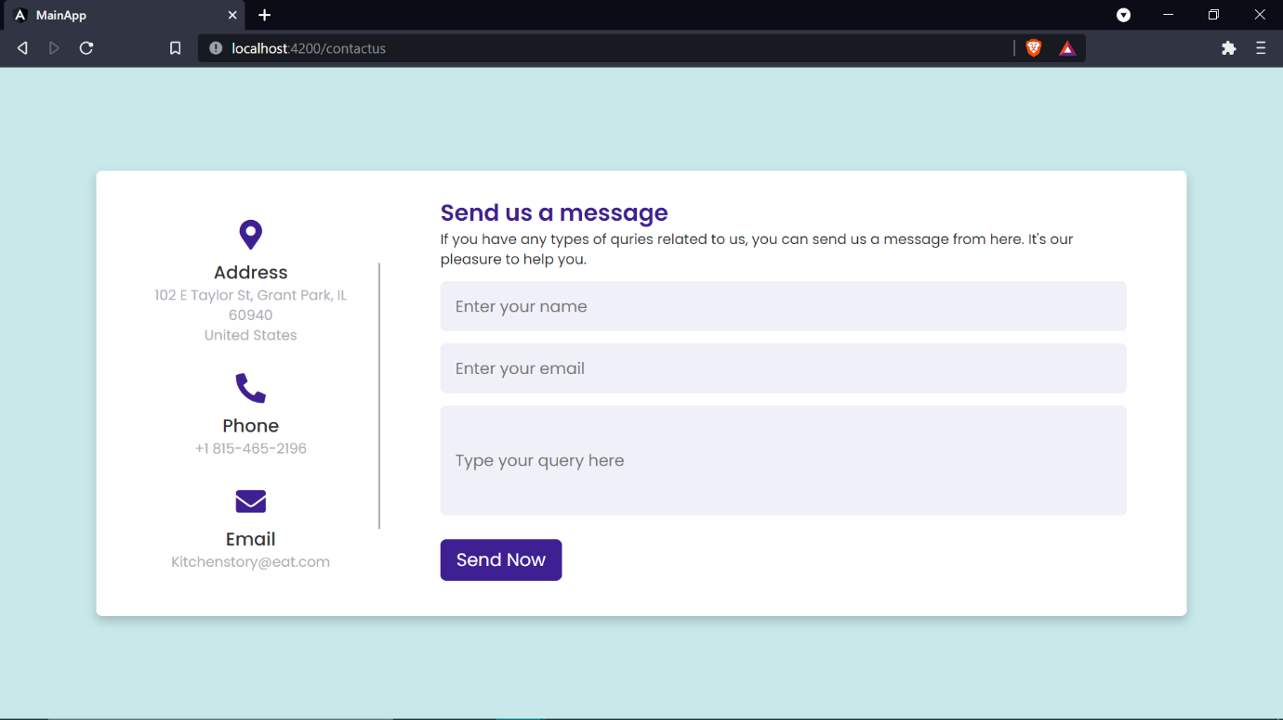

As of now only four types of products has been added (Honey, Eggs, Milk, Bread). If the user enters any other product an alert will pop up.  
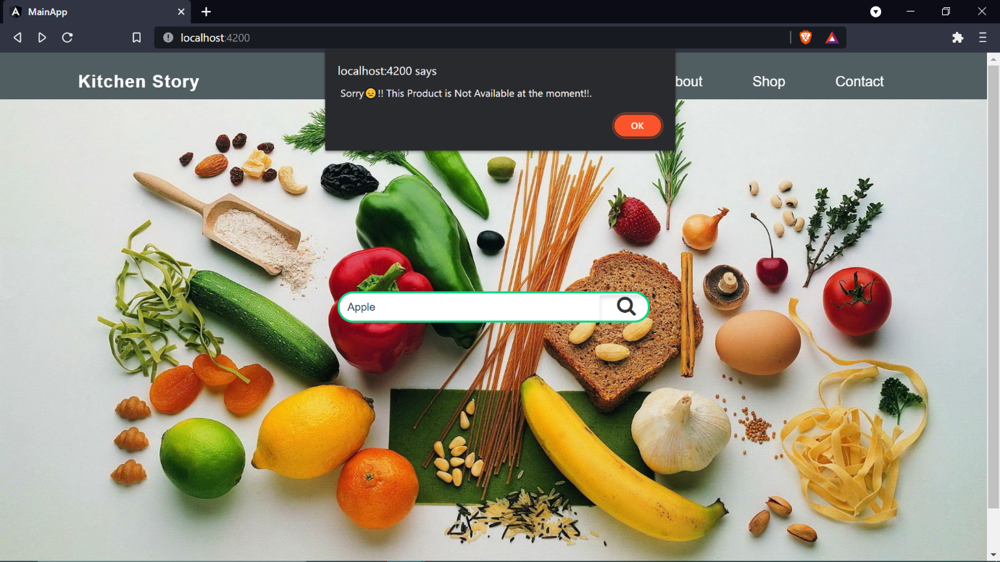

Searching any of (Honey, Milk, Eggs, Bread)  
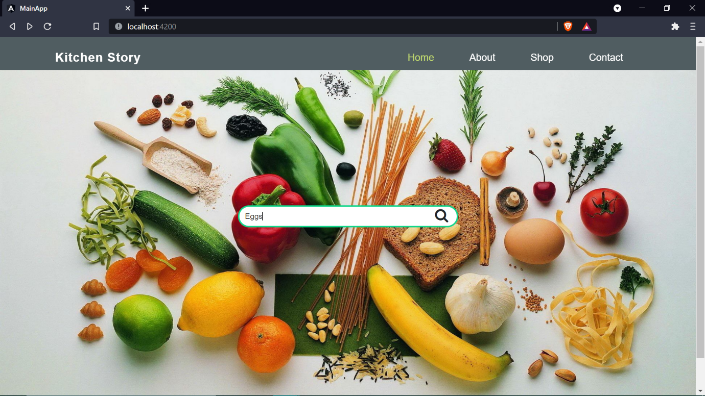

Select product (user need to select the checkbox in order to select the product of choice).  
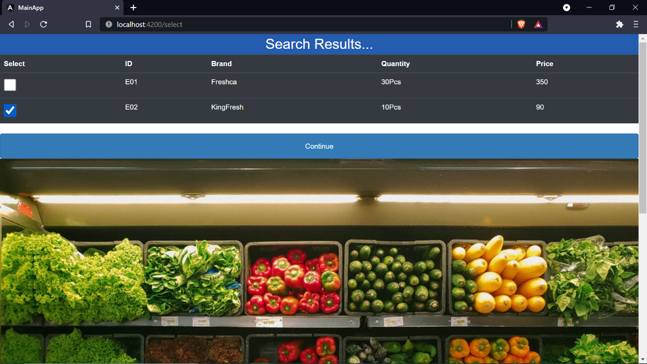

Cart Summary   
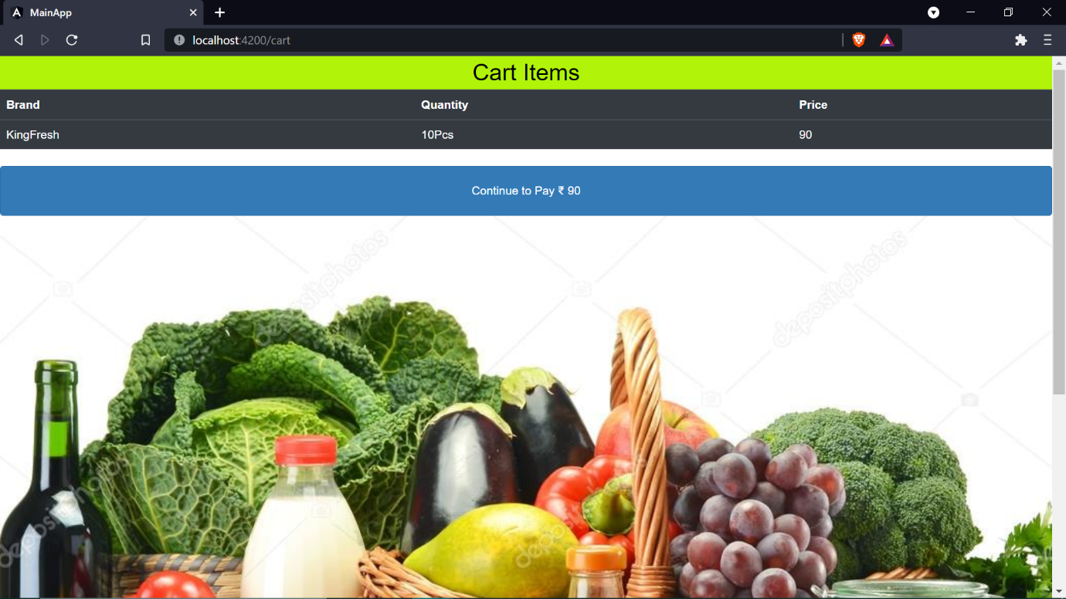

Payment and generating Order and Transaction ID  
